Thursday 7th January
The Whole Truth- Chapter 1
- What is the same about Marcie and Armitage?
__________________________________________________________________________________________________________________________________________
- What is different about Marcie and Armitage?
__________________________________________________________________________________________________________________________________________
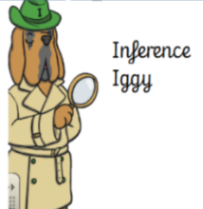
- Why did Marcie want to get her own back on Armitage?
____________________________________________________________________________________________
- What do you predict Marcie will do to get revenge on Armitage?
____________________________________________________________________________________________
 | True | False
By 5 o’clock Armitage had told 70 lies. (Page 9)
Marcie is an ordinary girl. (Page 2)
Everyone cares about Armitage telling lies. (Page 4)
Armitage’s head teacher is called Mr Smith. (Page 7)

