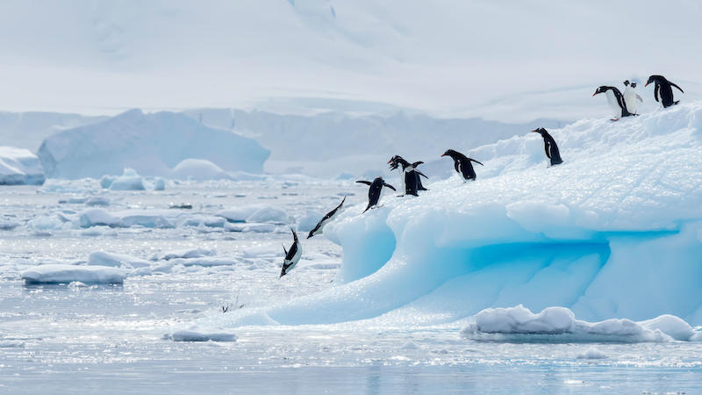

**Frozen Kingdoms - Learning Evaluation**

Link to prior learning

Link to future learning

New Words

The things I have learnt



Skills I have developed



What I enjoyed most



Rate my own understanding