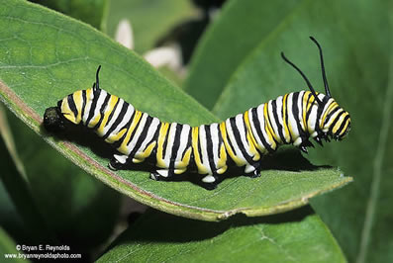
Look carefully at this picture of a caterpillar then try to sketch the caterpillar in the box below.

