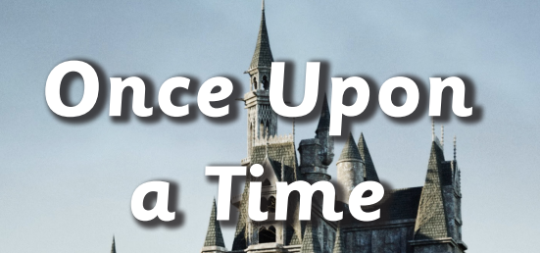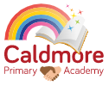

**Curriculum Map**

**Personal, Social and Emotional Development**

- Children are taught about Stranger Danger.

- Children continue to show independence in meeting own needs and make healthy choices.

- Children share own likes and dislikes.

- Children continue to further develop their relationships.

**Communication and Language**

- Children recall traditional tales and use visual prompts to verbally sequence events within a story.

- Children expand their repertoire of traditional tales and stories. Children are supported and encouraged to talk about familiar books.

- Children join in and recall repeated refrains from traditional tales.

- Children are supported to devise alternative endings to a story.

**Physical Development**

- Children use prior knowledge to explore healthy foods and make a vegetable soup in relation to the traditional tale *The Enormous Turnip.*

- Children develop their ability to use a comfortable grip with good control when using pens and pencils to mark make about traditional tales.

- Children use building equipment and materials to builds structures.

**Understanding the World**

- Children plant seeds and are supported to care for growing plants.

- Children explore different types of homes and discuss their own family homes with peers.

- Children explore and sort different materials.

**Literacy**

- Children are supported to engage in extended conversations about traditional tales.

- Children use some letter knowledge when mark making about stories.

- Children supported to use language to describe characters and settings from a story.

**Expressive Arts and Design**

- Children participate in pretend play and engage in imaginative small world play in relation to traditional tales.

- Children mark make and use materials to create characters from traditional tales. Character puppet making.

**Mathematics**

- Children are supported to make comparisons between objects of different size, weight, length and capacity.

**Enrichment**

**Theatre workshop visit, Jack and the Beanstalk planting, The Enormous Turnip – vegetable soup making, Mother’s Day Workshop, Easter Egg hunt**