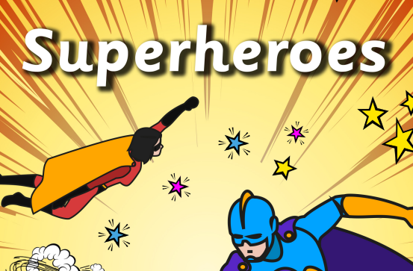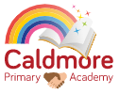

**Physical Development**

- Children continue to match their developing physical skills to challenges and activities within the setting.

- Children develop their ability to use a comfortable grip with good control when using pens and pencils to mark make with.

**Literacy**

- Children are supported to engage in extended conversations about stories.

- Children continue to develop their phonological awareness in Letters and Sounds adult-led learning.

- Children use some letter knowledge when mark making name.

**Expressive Arts and Design**

- Children participate in pretend play and engage in imaginative small world play in relation to people who help us in our community.

- Children continue to mark make through different means and are supported to give meaning to the marks they make.

**Communication and Language**

- Children continue to develop their listening and attention skills and are supported to increasingly pay attention during adult-led carpet or provision activity.

- Children continue to expand their repertoire of nursery rhymes and stories. Children are supported and encouraged to talk about familiar books.

- Children continue to develop their communication.

**Mathematics**

- Children are supported to explore and talk about simple 2D and 3D shapes.

- Shape exploring in learning environment.

**Spring 1 – Curriculum Map**

**Enrichment**

**People Who Help Us – Educational Visit, Family stay and play, Chinese New Year celebrations**

**Understanding the World**

- Children name, identify and discuss important people in their families.

- Children are supported to positively draw comparisons between different families.

- Children explore people who help us in our community and show interest in different occupations.

**Personal, Social and Emotional Development**

- Children explore who we are and what makes us special and unique.

- Children show more confidence in making friends and maintaining relationships with peers and familiar adults.

- Children learn about and explore healthy living: food, drink, teeth brushing and exercise.

- Children explore who is important to them.